Symantec System Recovery Monitoring Configuration Guide

Use these steps to upload and configure the necessary components in order to monitor Symantec System Recovery backups.

Pre-requisites: N-central 9.2.1.251

**Only tested with Symantec System Recovery 2013!**

Download and extract the custom service from the nrc

a. Name: **Symantec System Recovery**

b. Link:

Upload the custom services

a. Login to the N-central Admin Console (NAC)

b. Select Custom Services

c. Name: **Symantec System Recovery.xml** and **Symantec System Recovery Job List.xml**

d. If the service already exists, delete the existing service and add the new service

Upload the Service template

a. SO > Configuration > Monitoring > Service Templates

b. Click Import

c. Name: **Symantec System Recovery Service Template.xml**

Create a filter

a. SO > Configuration >Filters

b. Name: **Symantec System Recovery Devices**

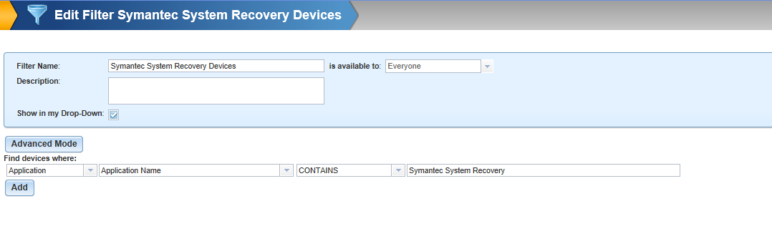

Upload the script to the Script and Software Repository

a. SO > Configuration > Script/Software Repository

b. Name: **SymantecSystemRecovery_JobPoll.ps1**

Create a Scheduled Task Profile

a. SO > Configuration > Scheduled Tasks > Profiles

b. Select Add

c. Name: **Symantec System Recovery job polling profile**

d. Select Add > Scripting

c. Schedule SymantecSystemRecovery_JobPoll.ps1 to run hourly on all **Symantec System Recovery Devices**

Create a Rule

a. SO > Configuration > Monitoring > Rules

b. Click Add

Name: **Symantec System Recovery**

Filter: Symantec System Recovery Devices

Scheduled Task Profile: Symantec System Recovery job polling profile

Service Template: Symantec System Recovery

Customers: all

Propagate to all new customer/sites: yes

Modify a Notification

a. SO > Configuration > Monitoring > Notifications

b. Select the Backup Manager notification profile

c. Add the appropriate recipients

d. Select the Trigger Details tab

e. Select the Backup Manager trigger

f. Add the Symantec System Recovery service

Configure the Backup Job Name on each server

Note: If you have a single job on each server with a consistent Job name, you can achieve this in a single step by modifying the Service Defaults for this service in the N-Central admin console.

Also, wait until the first script run has completed on all servers.

a. SO > All Devices View

b. Select the Symantec System Recovery Devices filter

c. Select each server

d. If you are unsure of the job name, click on the Symantec System Recovery job to copy the name to clipboard

e. Select the Symantec System Recovery service

f. Select the Service Details tab

g. Enter the Backup Job name